**Convert the  entity relationship model to a relational diagram**

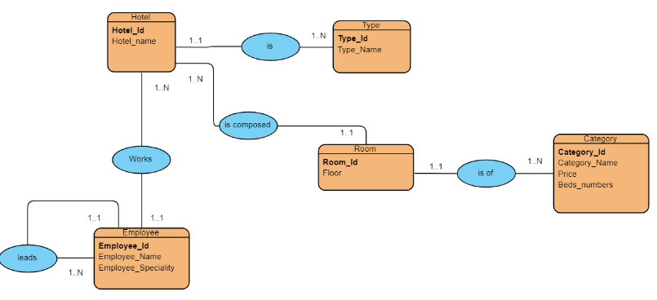

Hotel (**Hotel_id**, Hotel_name**, #Type_id**)

Type (**type_id**, Type_Name)

Room (**Room_id,** Floor, **#Hotel_id, # Category_id**)

Employee (**employee_id**, employer_name, employer_speciality, , #**Hotel_id)**

Category **(Category_id,** category_name, price, Beds_numbers)